Electroplating of 3D printed Components
(Step by step guide)

Jack O’Hara

Student Number: P2604133

Course: Aeronautical Engineering


Supervisor: Dr Richard Bailey

2022-2023

Safety equipment
1 pair of latex gloves
1 pair of goggles
1 lab coat

Equipment
1 scale
3 beakers
1 timer
1 microscope
1 stirring rod
2 Crocodile clips
1 Power supply unit
1 piece of copper
1 piece of Aluminium (10 cm x 4 cm)
6 grams of Copper Sulfate anhydrous
600ml of water
600ml of electro cleaning solution

Pre-calculations and background knowledge
Before the experiment can be carried out, calculations need to be completed to determine how long the power will be run and how thick you want the applied layer to be. To do this Faraday’s first and second law of electrolysis is used. The first of Faraday’s laws states that during electrolysis [1] “the amount of chemical reaction which occurs at any electrode under the influence of electrical energy is proportional to the quantity of electricity passed through the electrolyte”.

The second Faraday's law for electrolysis states [1] “that if the same amount of electricity is passed through different electrolytes, the masses of ions deposited at the electrodes are directly proportional to their chemical equivalents”.

Copper’s properties:
Density - 8.96 g/cm³
Atomic weight - 63.54 u
Valency - +2

To get the valency we use the chemical reaction formula as stated:

CuSO4 +H2O = Cu²⁺ + SO4²⁻

So for copper we can see that it is Cu²⁺. therefore its valency is +2.

Example
Calculate the theoretical mass of a Copper based plate that uses a current of 4 amps running for 15 minutes. Remember the Atomic weight of copper is 63.54 u and the density is 8.96 g/cm³.

Faraday's constant, F 96,485 C/mol

$Charge transferred = 4 c/s x 900 s = 3600 c (eq 1)$

To calculate theoretical mass of copper plated based on current we used the formula below

$charge transferred x \frac{1 mol c-}{96,485 c} x \frac{1 mol Cu }{2 mol e-}x \frac{Atomic weight}{1 mol Cu} (eq 2)$

Cancelling out the units our new formula is:

$charge transffered ÷ 96,845 c ÷ 2 x Atomic weight = 1.18 g Cu (eq 3)$

Steps for electroplating
- Take the Aluminium plate and hold it in a beaker of 600 ml of electro cleaner between 30-60 seconds. Rinse with water to ensure a clean surface and no excess cleaner is on it.

- Pour the 6 grams of Copper Sulfate anhydrous (CuSO4) into a beaker and add 600 ml of water, stir thoroughly. This will make Copper Sulfide hydrous, which is the solution that will be used to make it easier for cohesion to occur between target material and the substrate.

- Now pour the Copper Sulfate solution into the beaker that will be used for the electrolysis

- Next attach the crocodile clips to the Aluminium and Copper plates. Make sure the negative charge is connected to the Aluminium plate and the positive is connected to the Copper. This is because as the Copper in the solution is attracted to the Aluminium , the Copper atoms from the plate will replace the ones in the solution that are taken.

- Place both the Copper plate and Aluminium plate as shown in diagram 1 into the solution the crocodile clips should help the plates stay in place. Then connect the wires to the power supply. Make sure to set the power supply to 0.7 amp and as soon as it is turned on start the timer/countdown. This should be set or timed for 6:30 minutes.

- After the 6:30 minutes are up, turn off the power and pull out the Aluminium to allow for any excess solution to drip back into the beaker. Place on a kitchen towel and wipe down with a cloth.

- Then once the plate is dry cut it in half. This is to allow for the measurement of how thick the electroplating is and note down the results and compare to prior calculations.

Risk assesment

Risk | Cause | Severity (1-10) | Likelihood (1-10) | Management
Breakage | Knocking beaker off a table | 4 | 3 | Use a dustpan and brush to clean it up
Slippage (water) | Spilling or breaking the beaker | 5 | 3 | Use a mop or tissue
Slippage (Chemical) | Spilling or breaking the beaker | 5 | 3 | Use a mop
Eye irritation | Wiping the eyes after contact with the chemicals | 4 | 2 | Wash eyes out with clean water. Seek medical attention
Skin irritation | Getting chemicals on exposed skin | 3 | 4 | Wash skin with water. Seek medical attention

Results table

1st Experiment
Mass of Cathode (Aluminimum) (g)
Mass of Anode (Copper) (g)
Time (s)
Charge Transferred (c)
Mass of Cathode after deposition (g)
Mass of Anode after deposition (g)
Mass lost by Anode (g)
Mass of Copper plated (g)
Theoretical mass of copper plated based on current (g)
Plating efficiency based on current (%)
Plating efficiency based on mass difference (%)

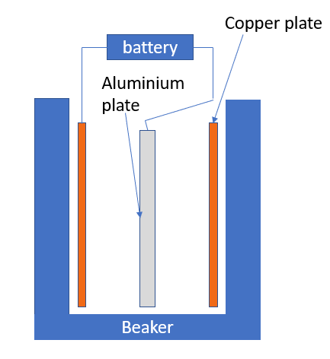

References
[1] Admin (2022) Faraday's laws of electrolysis - first & second law of electrolysis with videos, BYJUS. BYJU'S. Available at: https://byjus.com/chemistry/laws-of-electrolysis/ (Accessed: January 26, 2023).

